TITLE: Analytics for Health Care data

Name: SANTHOSH M

Team ID: PNT2022TMID15321

Upload the dataset to Cog Analytics, explore and visualize the dataset

1.Uploading Dataset to IBM Cognos Analytics:

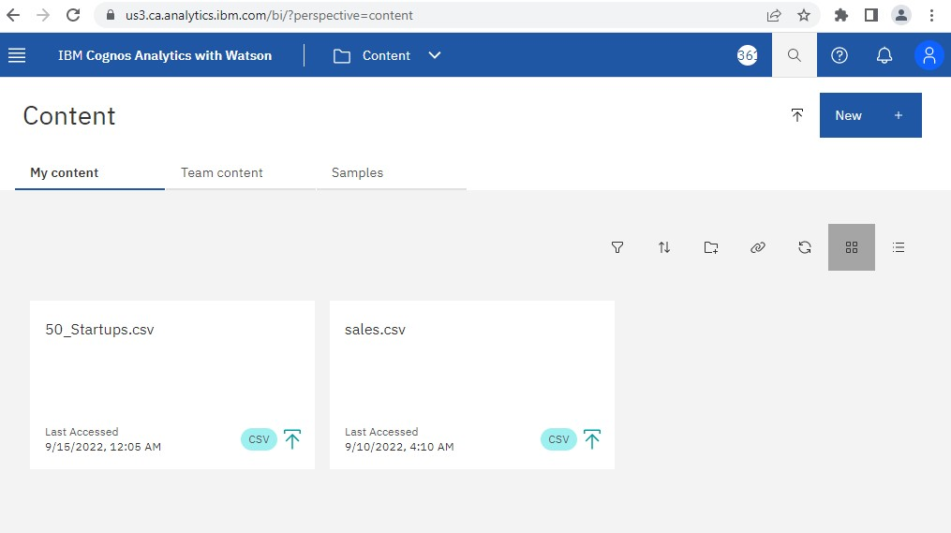

2.Data Exploration:



State Compared To

Administration

and Marketing Spend



Administ

ra

tion,

R&D

Spend

,

Marketing Spend

C

ompared

T

o

Profit

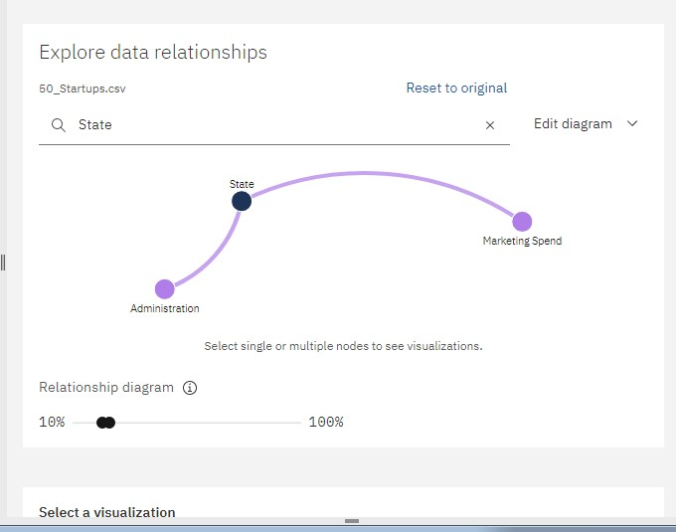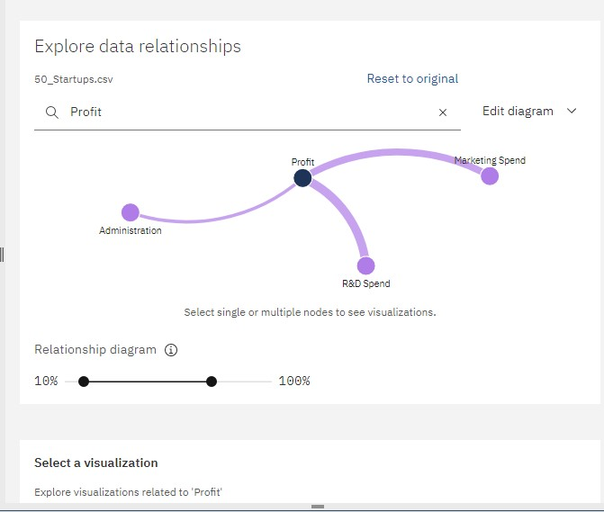

Marketing

Spend

Compared

T

o State ,

A

dministration,R

&D Spend

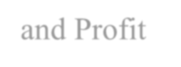

and Profit

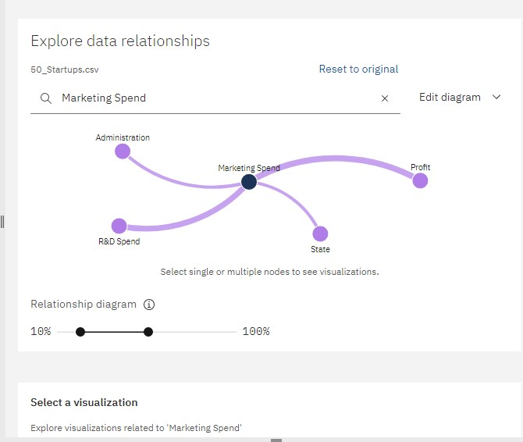

Administratio

n

Compared To

,

Marketing Spend

,State

and Profit

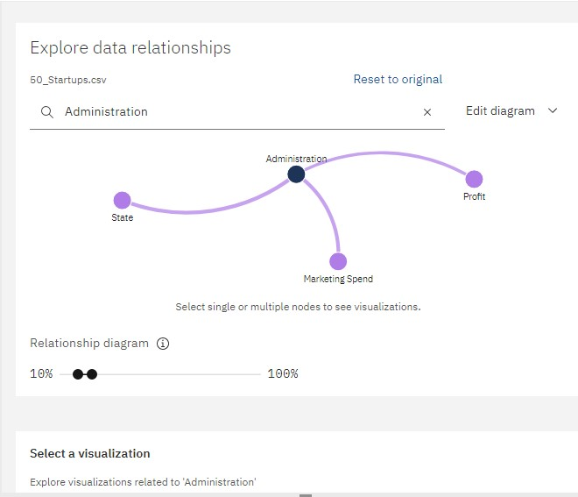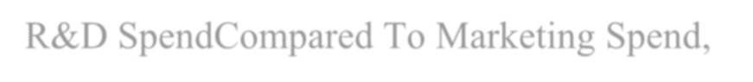

R

&D Spend

Compared

T

o

Marketin

g Spend

,



an

d Profit

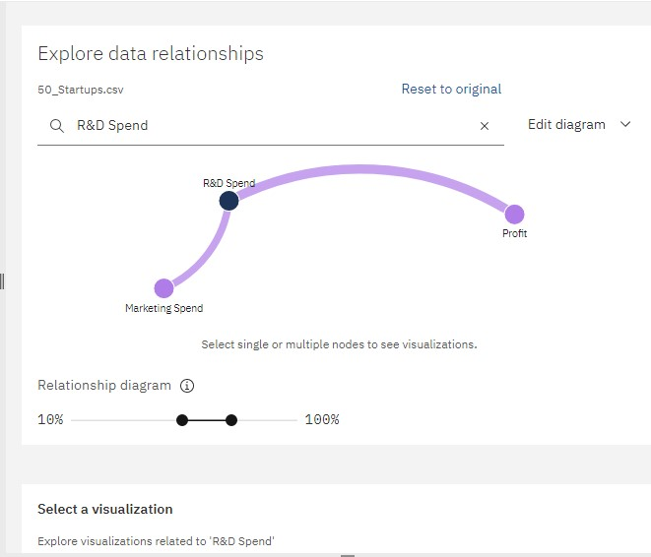

3.Data Visualization:

Bar chart Representation:

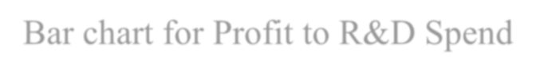

Bar chart for Profit to R&D Spend

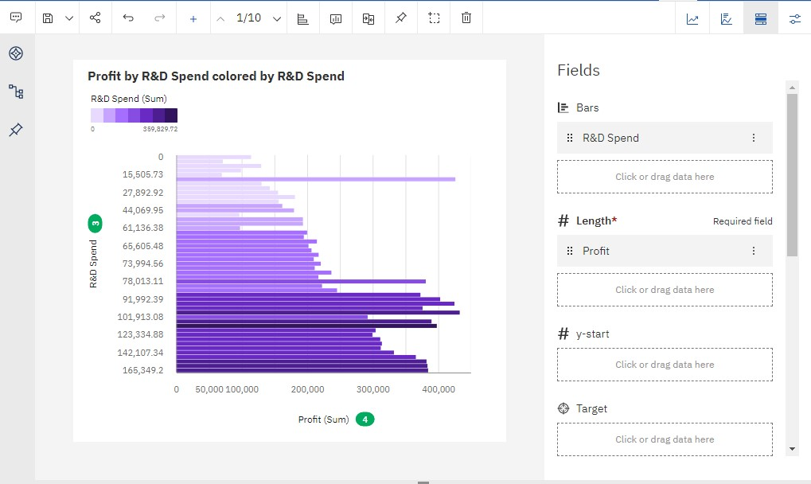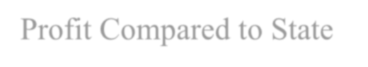

Profit Compared to State

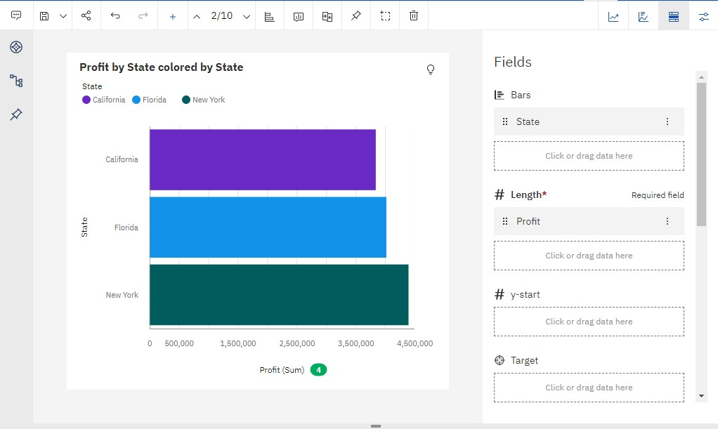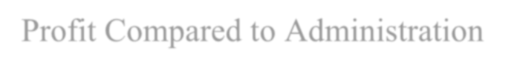

Profit Compared to Administration

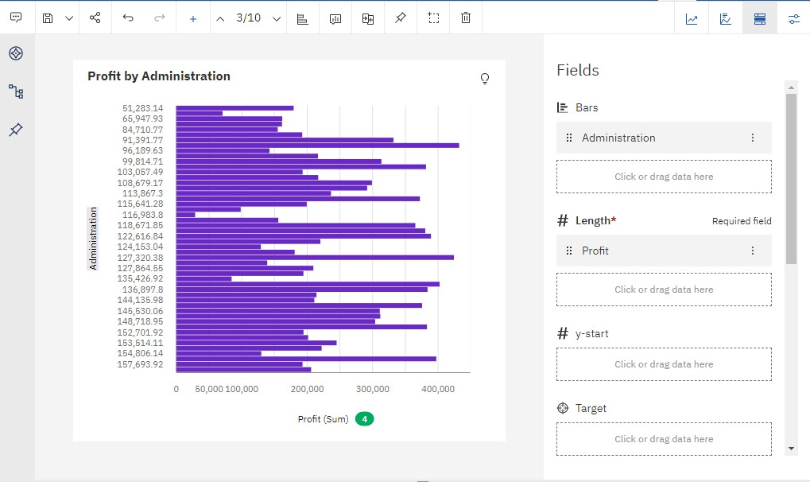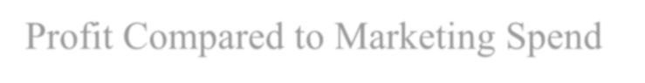

Profit Compared to Marketing Spend

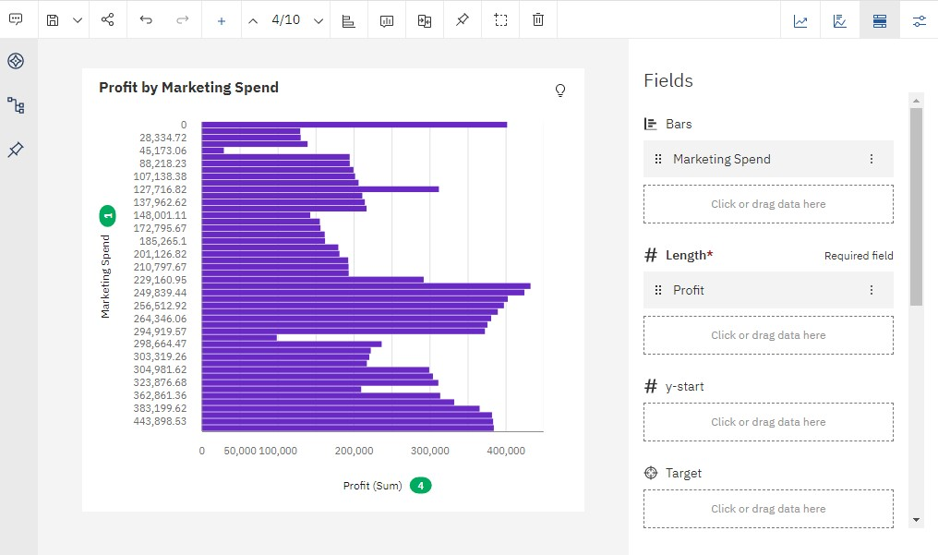

Pie Chart Representation:



Profit Compared to R&D Spend,Administration,Marketing Spend and

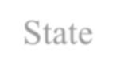

S

tate

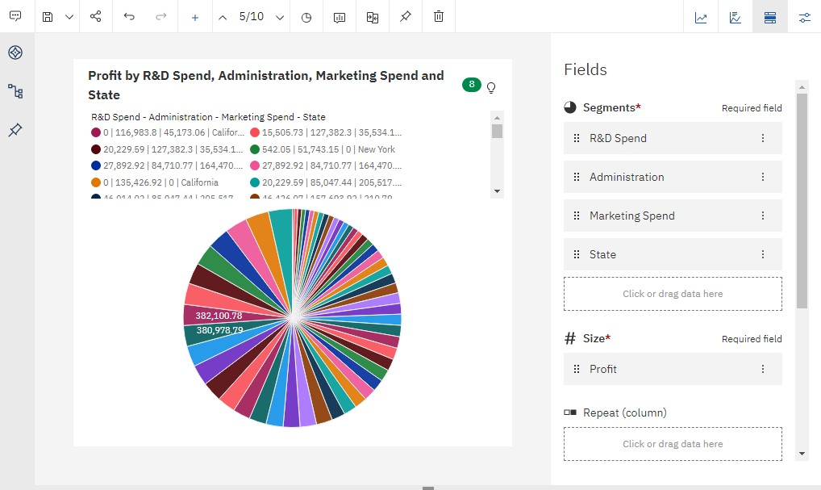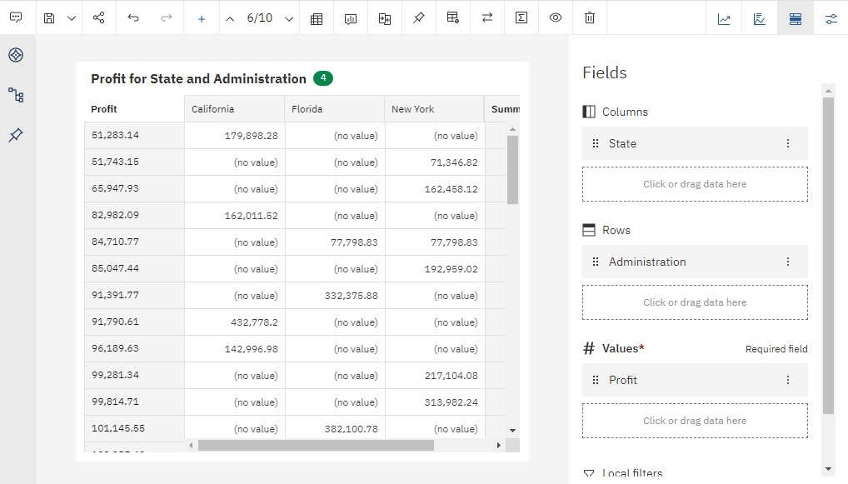

Profit For State and Administration

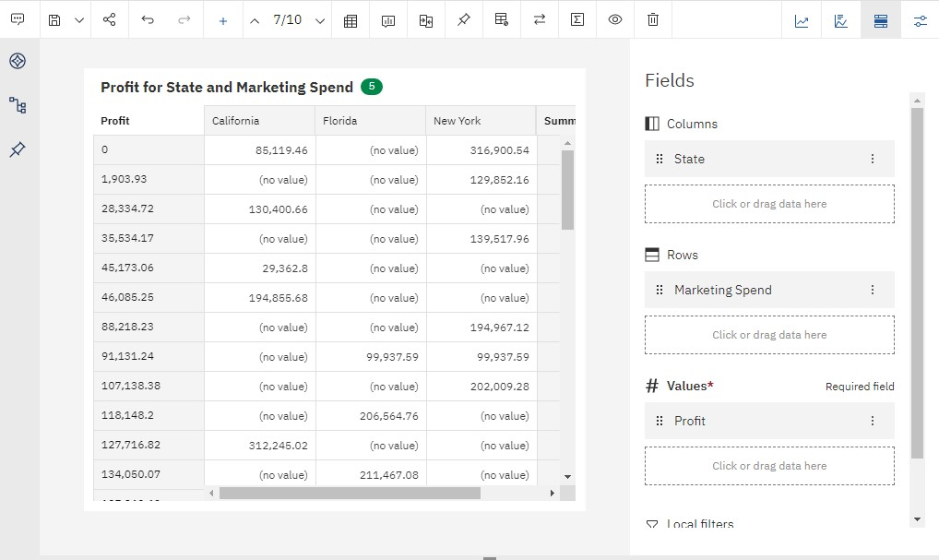

Profit For State and Marketing



Profit For State and Marketing Spend

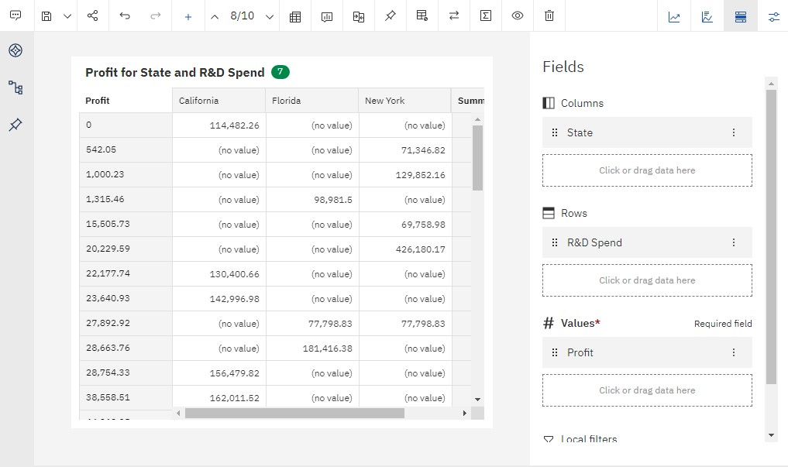

Profit For State and R&D Spend

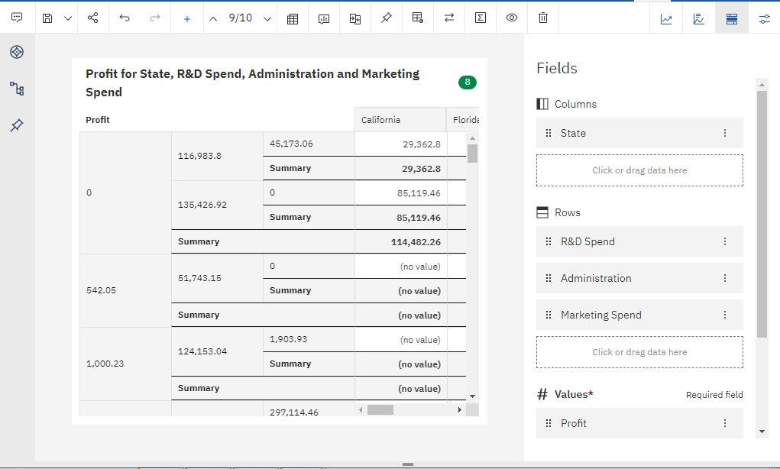

Profit For State,R&D Spend,Administration and Marketing Spend